Name: ___________________________________________________
Psychology 101
Brain Parts

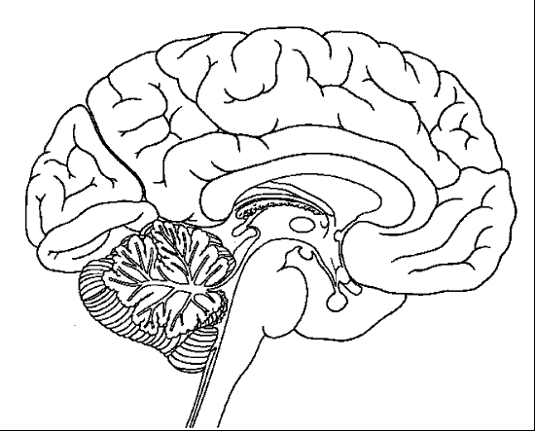
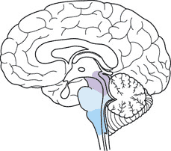

Hindbrain Midbrain

Color Code the following structures and state Color the area of the midbrain and state its function.
their functions.

0 Cerebellum-- 0 Midbrain--
0 Medulla--
0 Pons--
0 Reticular formation--

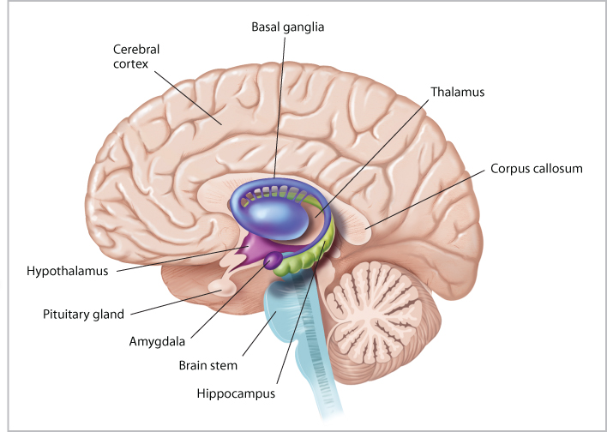

The Forebrain

Label the following structures and state at least one function of each:

Amygdala-- Hippocampus--
Basal Ganglia-- Hypothalamus--
Brain Stem-- Pituitary Gland--
Cerebral Cortex-- Thalamus--
Corpus Callosum--

