Name: ______________________________________________ Hour: _____
Psychology 101
Personality Project
30 Points

Your project on personality will consist of the following:

Part I: Discover your Personality Type 15 pts

Many online personality inventories can be accessed free. Many of these are based on Jung’s Typology and ask a number of questions that determine your level of the four basic preferences of personality. Carl Jung's theory of psychological types says each person is "wired" with different tendencies and preferences. Some of us are extraverted while others are introverted, some are "thinkers" while others are "feelers", and so on. The four preferences are:
- Extraverted or Introverted
- Sensing or iNtuition
- Thinking or Feeling
- Judging or Perceiving
Combining the four preferences in various ways results in 16 distinct personality types, each belonging to one of four temperaments.
Protectors (SJ)  - ESTJ - Overseer  - ESFJ - Supporter  - ISTJ - Examiner  - ISFJ - Defender | Creators (SP)  - ESTP - Persuader  - ESFP - Entertainer  - ISTP - Craftsman  - ISFP - Artist | Intellectuals (NT)  - ENTJ - Chief  - ENTP - Originator  - INTJ - Strategist  - INTP - Engineer | Visionaries (NF)  - ENFJ - Mentor  - ENFP - Advocate  - INFJ - Confidant  - INFP - Dreamer

For this assignment, check your email for the link needed to access the assessment:

http://www.humanmetrics.com/cgi-win/JTypes2.asp

Be sure you give yourself time to complete the test in one sitting. There are 72 questions that you can answer very quickly. The test takes about 10-15 minutes if you answer at a steady pace and understand the questions. You might want to have a dictionary handy to answer the questions accurately.

After you submit your results, you will be given your 4-letter type.

Take notes on the personality type you have and the 4 letters that designate your temperament. You will see Free tabs. Go to these tabs and find out: Possible career choices, people that share your type, both actual and fictitious.

Next, type a one-page paper including the following aspects:

A. A summary of the qualities included in your temperament.
B. Career options for your temperament.
C. At least one actual and one fictitious person who shares your temperament.
D. Your personal response as to the accuracy of the test.
Note: This is a paper, not a question-answer response. Write in paragraph form and be thorough. USE YOUR OWN WORDS. DO NOT COPY AND PASTE INFORMATION. Paper is due on Monday, March 23.

Part II: Personality Poster 15 pts

You will be supplied one piece of construction paper for your background.

Front: Find words and pictures from magazines to describe your personality. You may not write on the paper in any way shape or form. You can be creative with the lettering from a magazine. Please be school appropriate. Your poster should include pictures/words representing your results from the Jung Test, including your four-letter designation (e.g. ESTJ). (8 pts)

Back: Your name must appear on the back—remember, no writing anywhere, not even your name. Also on the back, include one word or one picture indicating the trait you would most want in a “significant other.” (2 pts)

This will be started on Tuesday, March 17 and continued/completed in class on Wednesday, March 18. Must be completed at home if not done in class.

Part III: Present your collage to the class. You must be in uniform (watch those boots and shirts), be serious, have eye contact with the audience, and speak in a clear voice. Be prepared to explain how you represented your findings from the Jung Test. (5 pts)

Presentations: Thursday, March 19.

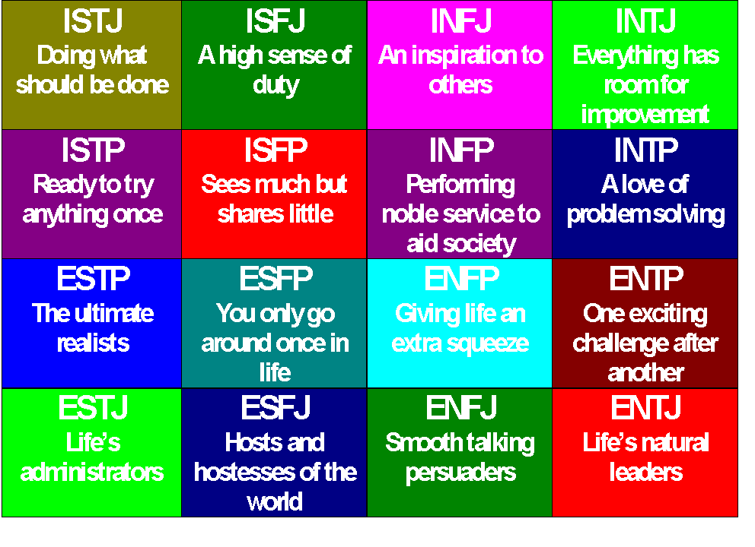

Name: ______________________________________________ Hour: _____
Psychology 101
Personality Project
Rubric

Assignment Requirements | Points Earned | Points Possible
Collage Front  Personality characteristics represented by pictures and letters (no words) including 4-letter designation from Jung Typology Test report |  | 8
Collage Back  One pic or word describing most important characteristic of significant other and name—no writing |  | 2
Presentation / Professionalism  Presentation completed in a professional manner, in uniform, using formal English |  | 5
One Paragraph Summary  Your temperament is explained in one paragraph using your own words, using accurate grammar |  | 5
Examples of People who Share Temperament and Career Options |  | 5
Personal Response  Response to accuracy of testing information |  | 5
Total |  | 30

