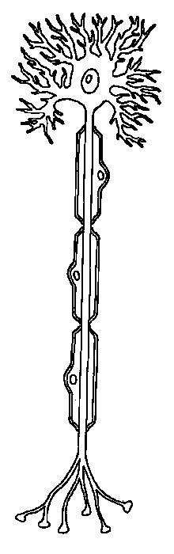
Name: ______________________________________ Hour:________

Psychology 101
Neuron Study Guide

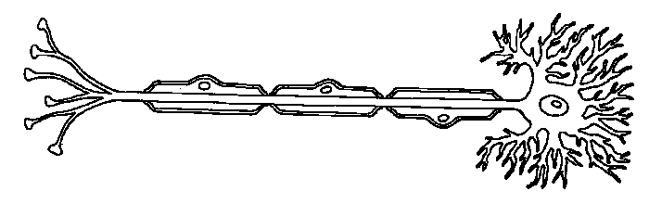
3. 4. 5. 6.

The sensory neuron:

The motor neuron:

The interneuron:

