Name:_________________________________________ Date: _____

Psychology 101
Section 13.2 and 13.3

13.2 Anxiety Disorders

The class of mental disorder in which anxiety is the predominant feature is an _______ disorder.

Generalized Anxiety Disorder (GAD)

1. GAD is a disorder consisting of chronic, excessive worry and three or more of the following
symptoms:

A.
B.
C.
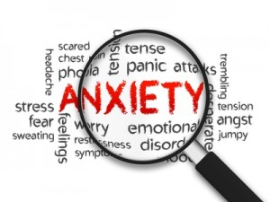
D.
E.
F.

2. About _______of North Americans are estimated to suffer from GAD sometime in their lives.

3. It occurs more frequently in ________socioeconomic groups than middle and upper income groups, and is _________ as common in women as in men.

4. Both ________________ and _______________ factors contribute to GAD.

5. Treatment with ______________can be helpful, but not for everyone and some side effects can be serious.

Phobic Disorders

6. A phobic disorder is a marked, persistent and excessive ________and __________________ of specific objects, activities, or situations.

7. A ___________ phobia deals with fear of a particular ________or situation. Give an example:

8. A ___________ phobia involves an irrational fear of being publicly humiliated or embarrassed. Give an example:

9. The _______________________ theory of phobias indicated people have a predisposition toward certain fears.

10. Abnormalities in the neurotransmitters _________________and ______________ are more common in people with phobias. The abnormally high activity in the ________________ has been seen in people with phobias.

11. There is a possibility of phobias being learned through ________________ ___________________ as well.

Panic Disorder

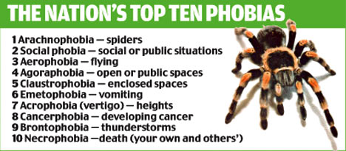
12. A panic attack lasts for a few minutes and includes the symptoms of

A.
B.
C.
D.
E.
F.

13. A common complication of panic disorder is a______________, a specific phobia involving a fear of venturing into public places.

14. Panic attacks may be due to the _________ of _________ itself.

Obsessive-Compulsive Disorder (OCD)

15. OCD includes symptoms of repetitive, intrusive thoughts called ______________, and ritualistic behaviors called _________________ designed to stop the thoughts interfere with an individual’s functioning.

16. There is a moderate _________________ heritability for OCD.

17. The part of the brain that has been found to have a link to OCD is the ___________ ____________.

13.3 Mood Disorders

Mood disorders take two main forms: ________________and __________ _______________.

Depressive Disorders

18. Depressive mood disorders are _________________, ____________, and fall outside the range of socially or culturally expected responses.

19. Major depressive disorder is characterized by a depressed mood lasting for more than ______ weeks, with feelings of worthlessness, lack of pleasure, lethargy, and sleep and appetite disturbances.

20. Those that experience depressive moods in a _________________pattern exhibit seasonal affective disorder (SAD).

21. More ___________ than __________ are diagnosed with depression. This might be due to women having a greater willingness to seek help. It might also be due to hormones which influence depression.

22. Some women experience depression following childbirth called _____________depression.

23. A __________________ model has yet to be developed; also, the role of brain regions is not understood.

24. Helplessness theory suggests that individuals prone to depression view negative experiences as caused by notions that are ______________, ____________, and global.

Bipolar Disorder

25. Those with bipolar disorder show cycles of abnormal, persistent high mood, ______________, and _________________.

26. Other symptoms of bipolar disorder include:
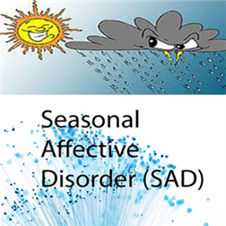
A.
B.
C.
D.
E.
F.

27. This disorder has the highest rate of ______________________.

28. Most often interactions of _____________genes (polygenic) are found in families with bipolar disorder.

29. Biochemical _________________ might be involved, and _________________ factors play a role.

30. A significant minority of people with bipolar disorder are highly ______________, a______________, or otherwise outstanding in some way.

