Name: _______________________________________ Hour: ______
Psychology 101
Chapter 3 Project

Make a Poster of a Human Brain

PURPOSE:
The purpose of this assignment is to help you become more familiar with the structure and function of the human brain.
PROCEDURE AND EVALUATION:
This assignment is a chance for you to accept the challenge of making a detailed poster of a human brain which shows the different areas and their function(s). There are excellent diagrams on the Web from which to work and illustrated books may be borrowed from me on a first-come, first-served basis.
BRAIN POSTER:
Create an original poster (20" x 30" size) which details brain structure and function. You must use a rigid and flat poster board-- foam board. (If you do not use a foam board, your grade will be no higher than a C). Foam board can be obtained at most craft or art supply stores. I have also seen them at the dollar stores. All work must be done on the foam board itself, large enough for brain parts to be seen clearly.
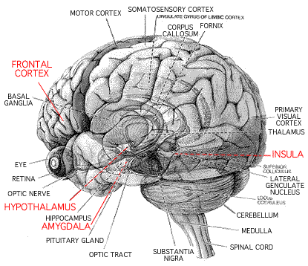
All art work must be original and large enough to show various brain areas clearly. Do not simply cut pictures of a brain from some other source and paste them on a board. Color is required. Neatly use colored pencils, fine-tip markers or crayons.

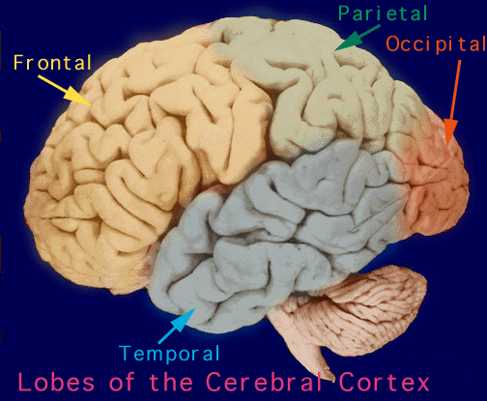

Scoring:
45-50 points - "A" :

Great Work! Not only are all structural areas clearly labeled and a full description of function(s) given, but also the poster is very aesthetically pleasing to look at. It would be hard to improve on it. Poster includes parts not found in your textbook. Outstanding Work! Remember: You must have all the parts in our text PLUS a lot more AND the function of the part must be given.

40-44 points - "B" :

Very nice brain. Not only are the areas we discussed in class and that are in the text clearly labeled, but more areas from other sources have been included and their function(s) are also clearly and completely indicated. The format described above for your poster has been followed. Good Job! You must have all the parts in our text PLUS a little more AND the function of the part must be given!

35-39 points - "C" :

We clearly have a brain here. All of the areas we discussed in class and that are in your text are clearly labeled: the hemispheres, lobes of the cerebral cortex complete with convolutions and fissures, as well as structures of the brain stem and limbic system are clearly recognizable (and color coded). The functions of labeled areas, however, are incomplete, and/or there's been a violation of format requirements (above).

30-34 points - "D" :

Well, your model or poster creates something which generally resembles a brain. Some of the areas we discussed in class and that are in your text are labeled and the overall structure is sort of recognizable, but not much effort was put into the work. There also may have been a major violation of format requirements (above).

You have about two weeks to complete this project. This project counts as a paper/project grade.
DO NOT wait until the last minute.
This project is due on Monday, October 27th at the beginning of the day. I will be in Senior Row to collect projects in the morning, so you do not have to worry about carrying or storing them. Posters turned in after 8:00 AM are late and will receive a point deduction.
Assigned: Friday, October 10

